## Exercise: Shell scripts

1. Write a shell script to get the current date, time, username, and current working directory.

========================================================

#!/bin/bash

echo "Hello, $LOGNAME"

echo "Current date is `date`"

echo "User is `whoami`"

echo "Current directory `pwd`"

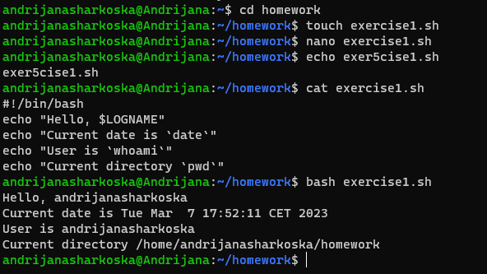

2. Write a shell script that prints “I love learning about DevOps” on the screen. Message should be a variable.

========================================================

#!/bin/bash

message=”I love learning about DevOps”

echo “$message”

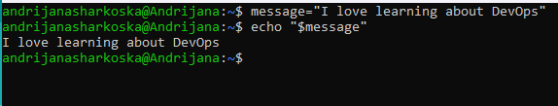

3. Write a shell script that displays “plan code build test release deploy” on the screen with each appearing on a separate line.

========================================================

#!/bin/bash

echo “plan code build test release deploy” | xargs -n1

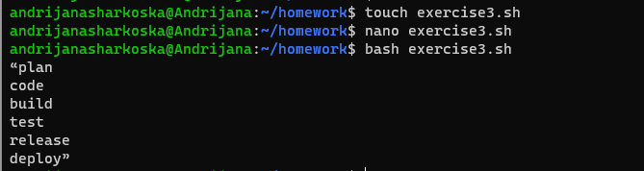

4. Write a shell script that prompts the user for a name of a file or directory and reports if it is a regular file, a directory, or another type of file. Also perform a ls command against the file or directory with the long listing option.

========================================================

#!/bin/bash

read -p "Enter a file or directory name: " name

if [ -f "$name" ]; then

echo "$name is a regular file."

elif [ -d "$name" ]; then

echo "$name is a directory."

else

echo "$name is not a regular file or directory."

fi

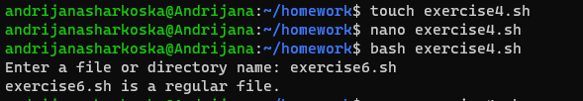

5. Use arguments in a script. Total number of arguments should be three.

========================================================

#!/bin/bash

echo "First arg: $1"

echo "Second arg: $2"

echo "Third arg: $3"

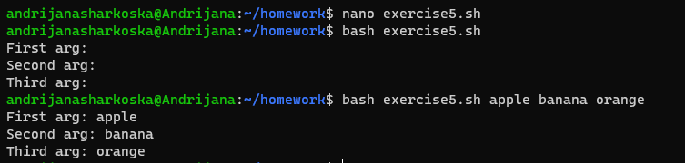

* Here first I displayed the content inside the file, then passed the three arguments.

6. Write a script that will output your name out of a variable and will display the server uptime

========================================================

#!/bin/bash

echo "Enter your name:"

read

uptime=$(uptime -p)

echo "Server uptime is: $uptime"

